

WEEK 2, T3 - 2015
Score ( x / 25 ) | %

LAKELAND SHS MATHEMATICS

MATHEMATICS METHODS UNIT 2
test 1 – Part a

NAME: ______________________________ Time allowed: 20 min

CALCULATOR FREE AND NOTE FREE SECTION

1. [2, 2, 3, 3 = 10]
Evaluate each of the following leaving your answer as a whole number or fraction.
(a) 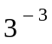

(b) 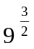

(c) 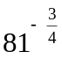

(d) 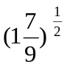

2. [3]
(a) Write 0.062 in scientific notation.

(b) Write 1.8 × 10⁴ as a normal number.

(c) Write 9.33 × 10^{–6} as a normal number.

3. How many significant figures are in 0.00243? [1]

4. An exponential function is given by f(x) = 6 × 4^{x}. Calculate the value of f(0). [1]

5. What is the y-intercept of the exponential graph y = 2.1 × 3^{x} [1]

6. Solve the following for x, showing full algebraic working. [2, 3, 2 = 7]

- 4x² = 100

(b) 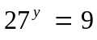

(c) 3^{3x–1} = 3

7. [2]
The population of a bacteria culture is initially 2000 and increases by
25% every hour. Write the growth function for the number of bacteria after h hours.

-

WEEK 2, T3 - 2015
Score ( x / 32 ) | %

LAKELAND SHS MATHEMATICS

MATHEMATICS METHODS UNIT 2
test 1 – Part B

NAME: ______________________________ Time allowed: 30 min

CALCULATOR AND NOTES ASSUMED

8. [2,1,2, 6 = 11]

The population of Tasmanian Devils in a specific region of Tasmania was studied as scientists tried to prevent the disease that is killing them. They recorded the number of infected animals. The results are as follows:

Year | 1999 | 2000 | 2001 | 2002 | 2003 | 2004 | 2005
Population (infected) | 100 | 120 | 144 | 173 | 207 | 249 | 299

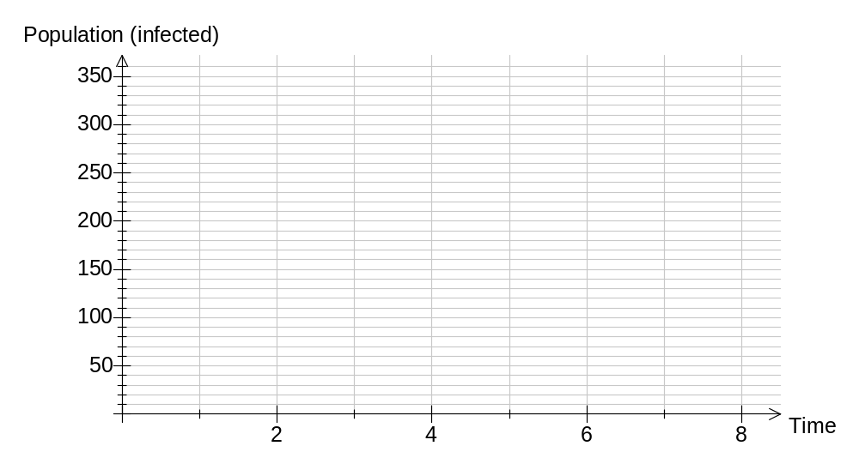(a) Plot these points on the graph below, using 1999 as t = 0.

(b) Does the population infected follow a linear or exponential model?

(c) How many Tasmanian Devils will be infected in the region by 2010 (if the trend continues)?

(d) A new vaccine is tested to reduce the infection rate. How many Tasmanian Devils will be infected in the region by 2010, if the vaccine reduces the rate of infection by 60%, and is administered in 2007?

9. [3]
The population of a threatened species is initially 1500 and decreases by
25% every year. Find the decay function and use it to estimate the population
after 4 years.

10. [2, 2, 3 = 7]
Solve the following for x, showing full algebraic working. Leave your answer in fractional form where appropriate.

(a) 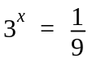

(b) 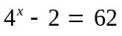

(c) 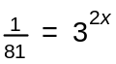

11. [2, 3, 2, 4 = 11]
Simplify the following terms, expressing your answer with positive powers.

(a) 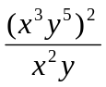

(b) 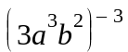

(c) 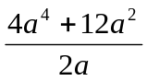

(d) 